**Call Steward Document**

Team member:

Liang Xubin (3035420053)

Tu Chao (3035419250)

Zhou Guancong (3035420211)

(Order by surname)

**1. Description**

**1.1 Technique**

**IDE: Android studio**

Android Studio is the official integrated development environment (IDE) for Google's Android operating system, designed specifically for Android development.

**BroadcastReceiver**

Android apps can send or receive broadcast messages from the Android system and other Android apps. In this APP, when receiving incoming call, Services.chkIncomingPhoneNumService will start.

**Service**

Service are long running operations in the background. In this APP, Services.chkIncomingPhoneNumService will compare phone number in user phone book with incoming phone number. If the incoming calls are not included in phone books, this service will download graphical warning message and pop this message up.

**WindowManager**

WindowMagnager is the interface that apps use to talk to the window manager. Use Context.getSystemService(Context.WINDOW_SERVICE) to get one of these. In this APP, we use WindowMangager to pop-out the graphical warning message.

**1.2 Method**

**Bitmap getPicture(String path)**

Input URL and output a picture in Bitmap format.

**Cursor getContacts()**

Gain the ID of the people in phone book.

**Cursor getPhones(long id)**

According to the input ID, get the phone number of input ID.

**String get_attribution(String url_s, Map para_input,String method)**

Get the attribution of input number.

**String StringFilter(String str)**

Input string and use regular expression to filter, output the number of string.

**String url_str(Map<String,String> data)**

Use to get String of the URL, which is the API address of http://apis.juhe.cn/mobile/get

**List<Map<String, Object>> get_call_log()**

Get the call log.

**void query_attribution(String phone)**

Inquiring the attributions of input number.

**1.3 Demonstration**

1.3.1 welcome interface



In the welcome interface, we want to get some permission. The detail of getting permission is showed in the <Read me> document.

1.3.2 pop-up graphical warning message

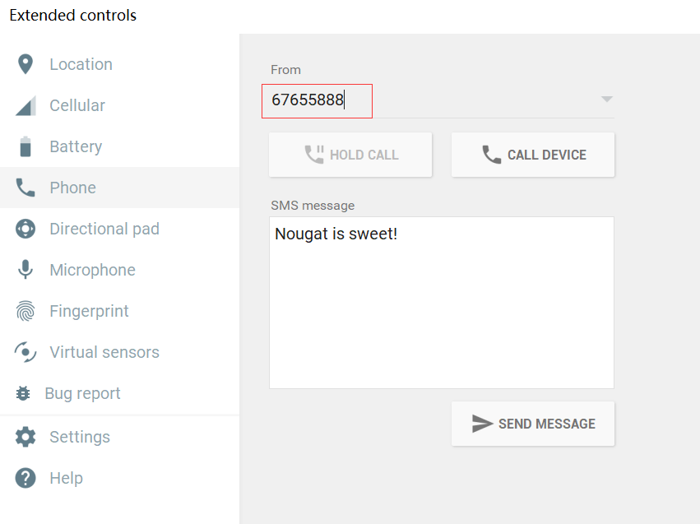

Phone number 67655888 is not include in our phone book. Now make the phone call.

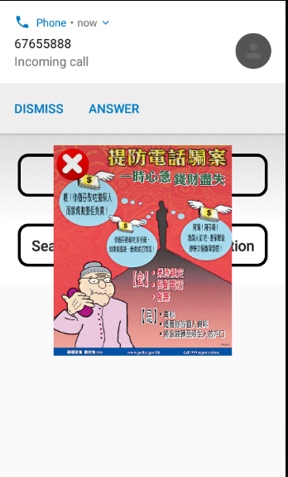

Pop up the graphical warning message. Click the <close> button in the left-upper side, you can close the picture.

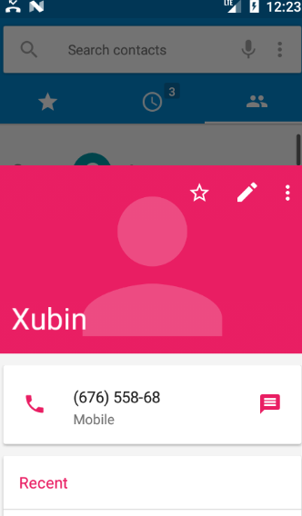

Phone number 67655868 is included in the phone book. Now, make the phone call.

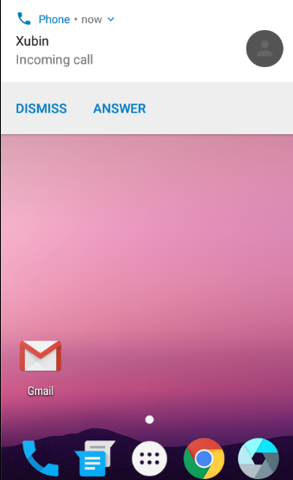

The graphical warning message will not be displayed.

*This function ignores the influence of area number.

**1.4 Special feature**

This APP is not only a service that can pop up graphical warning messages when the incoming calls are not included in their phone books, it also contains welcome interface which is attractive and some additional functions which can help user check their call log and search attribution of incoming phone.

**2. Additional feature**

We add two additional features: View the call log and Search Phone Number attribution.

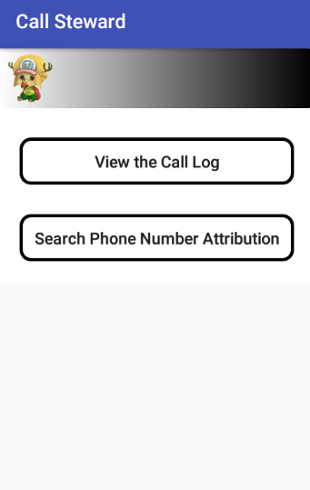

**2.1 View the call log**

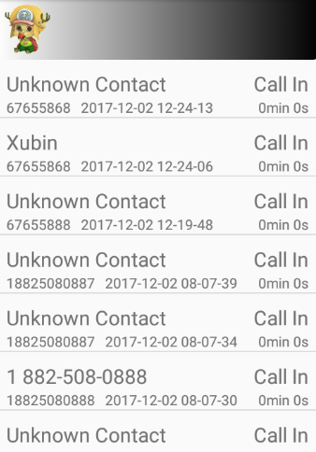

You can see your call log when click the button <View the call log>.

**2.2 Search phone number attribution**

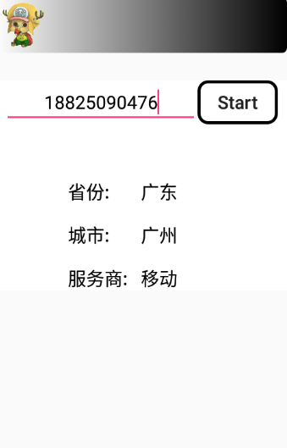

Click the button < Search phone number attribution >. Then input a phone number and click <Start>, you can get the attribution of this phone number.

* you can only get the attribution of phone numbers which are from mainland China.

**3. Limitation**

3.1 Ignore the influence of area number

Because we do not have enough knowledge of the storage rule of the phone numbers in user’s phone and the rule of area number, the comparison method of incoming number and phone book number is that we remove the symbols of phone number and just compare numbers. (We ignore the influence of area number.)

3.2 Have to keep the phone connect the Internet

The pop-up picture is got through Internet and search attribution will need Internet. So, you have to keep your phone connect the Internet.

3.3 Limitation of searching the attribution of phone numbers

Because the API of searching the attribution need to be paid, we only use the trial version, which means that the frequency of searching the attribution is 200 per day and you can only get the attribution of phone numbers which are coming from mainland China.

**4. Member Contribution**

Liang Xubin completed requirement (4), (5);

Tu Chao completed additional features;

Zhou Guancong completed requirement (1), (2), (3).

Referemce:

[1] https://en.wikipedia.org/wiki/Android_Studio

[2] http://androiddoc.qiniudn.com/reference/android/view/WindowManager.html

[3] Chim, T.W., android apps development part3.

[4] Android基础入门教程. Retrieved 2017-11-01, fromhttp://www.runoob.com/w3cnote/a

ndroid-tutorial-intro.html.